Question 6 [6 Points]
Create a shell script metrics.sh that analyzes a text file input.txt.
The script should display:
• Longest word
• Shortest word
• Average word length
• Total number of unique wordsUse pipes and commands such as tr, sort, uniq, wc.

-----
Script:
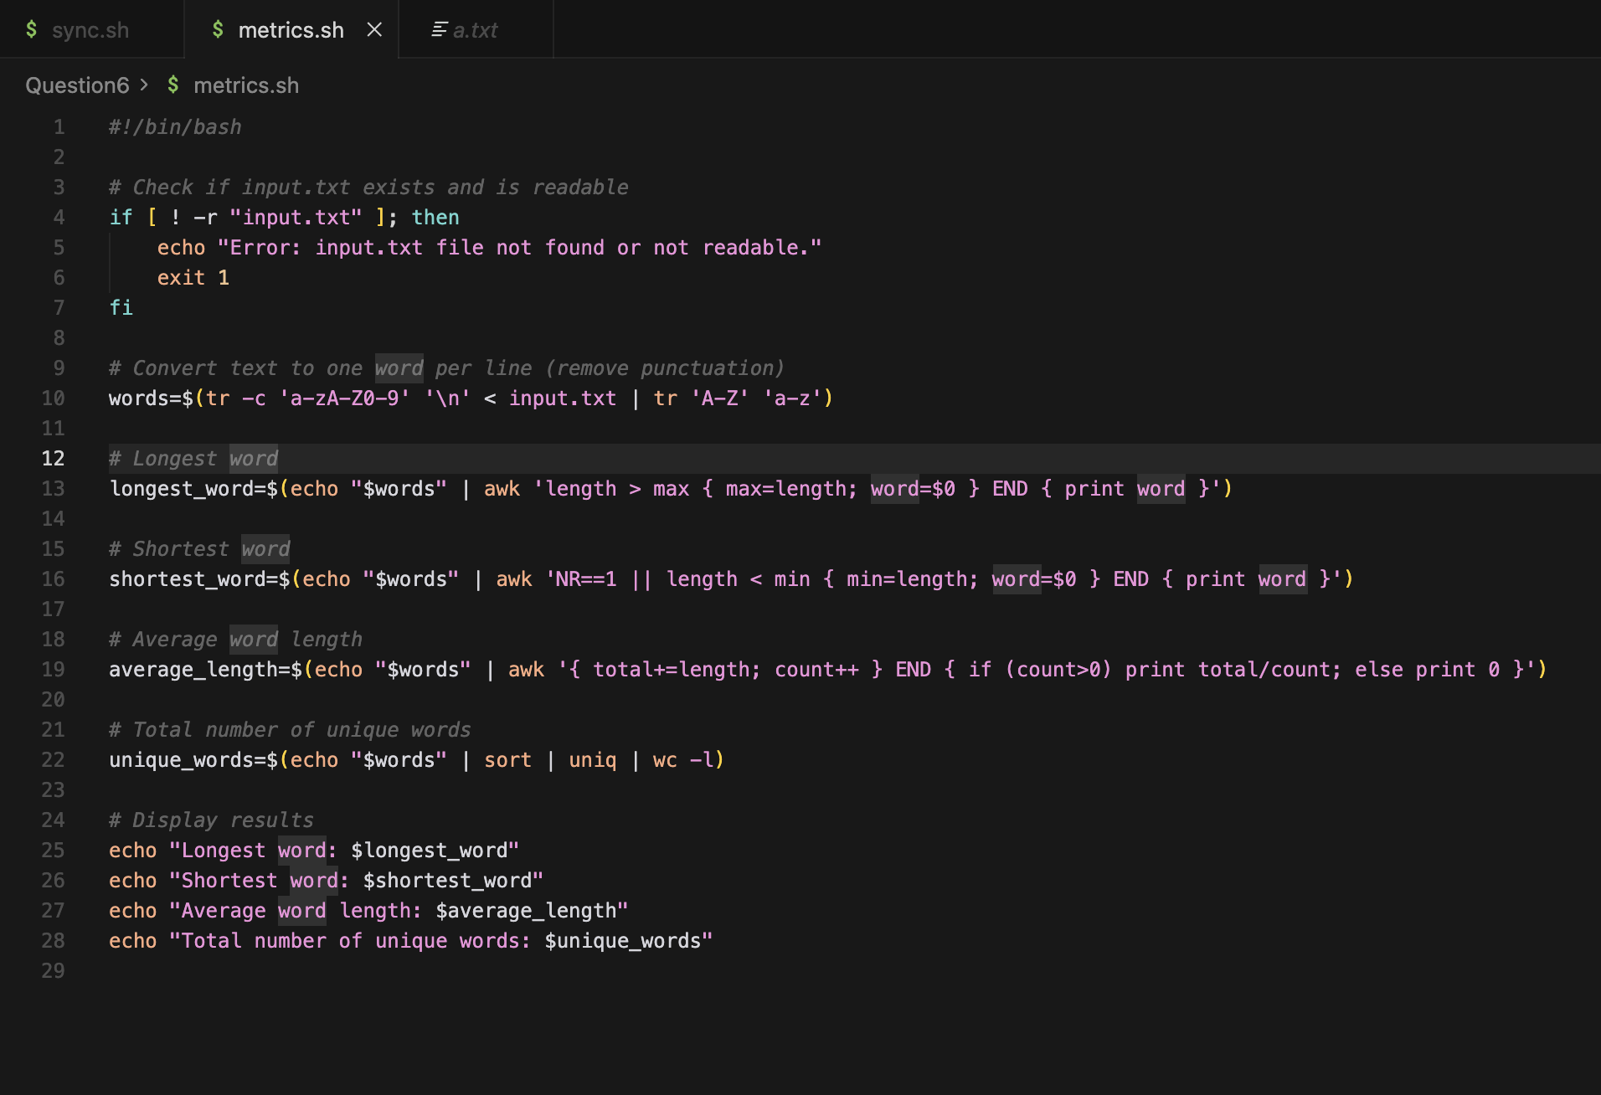
Explanation:
words=$(tr -c 'a-zA-Z0-9' '\n' < input.txt | tr 'A-Z' 'a-z' | grep -v '^$')
<input.txt : sends the content of input.txt into the command
tr -c 'a-zA-Z0-9' '\n' : replace everything except letters and sigits with a new line
longest_word=$(echo "$words" | awk 'length > max { max=length; word=$0 } END { print word }')
length > max { max=length; word=$0 } : length -> length of current word
max -> stores the maximum length found
$0 -> entire line
END { Print word } : Prnt the longest one
awk : Text-processing tool which works line by line

Output:
